PRESS RELEASE
EMBARGOED FOR RELEASE: 08 October 10AM (CEST)

Mazars publishes Tech Train study revealing global technological familiarity, investment and implementation levels
- China and India dominate across the board, France and UK lag behind
- Artificial Intelligence is the technology most leaders feel familiar with
- India has greatest appetite to increase technological investment

Mazars publishes thought leadership revealing the extent to which the global C-suite are familiar with, investing in, and implementing five key workplace technologies: Artificial Intelligence (AI), Blockchain, Enterprise Resource Planning (ERP), Internet of Things (IoT) and Robotic Process Automation (RPA).
8 October 2019: Mazars, the international audit and advisory firm, today announces the release of its new report “Are you missing the Tech Train? Global investment and implementation surrounding transformative technologies”. More than 600 C-suite executives based in six countries (China, France, Germany, India, UK and US) and working in different industries, sectors, and organisation sizes share insight on these game-changing technologies, their investment appetites, the barriers they face to technological implementation - and how to overcome them.
CHINA AND INDIA LEAD, FRANCE AND UK LAG
Familiarity: Leaders in China are the most familiar with these five key technologies (79%), followed by Germany (71%), India (69%), US (64%). France and the UK come bottom (53%, 44%.) AI is the technology most respondents feel familiar with.
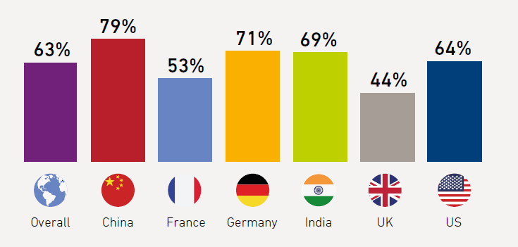
Exhibit 1: Familiarity levels of the five technologies – AI, Blockchain, ERP, IoT, RPA - by country
Investment: Respondents in India have the greatest appetite for increasing the budgets they dedicate to these five technologies. France and UK respondents are most reluctant to increase their budgets (as below.)
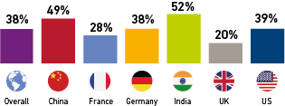
Exhibit 2: Percentage of respondents who plan on increasing the share of the IT budgets
in all five technologies by 10% or more

Implementation: China and India are the most likely to have implemented at least one of the technologies and share the highest adoption rates for all five technologies. France and UK are the least likely to have implemented any of the technologies.
Sector splits
Insurance and manufacturing are the top sectors where the five technologies have already been implemented. Leaders in the public sector were least likely to have implemented any of the five - 50% of respondents working in the public sector said ‘nothing is happening’ with the five technologies.
Benefits and barriers
Cost savings (27%), business model transformation (26%) and improvements in quality (24%) are the top three expected benefits of the five technologies.
The most cited barriers globally to implementing technologies are: obtaining necessary financial resources (25%), finding talent and skills that can fully grasp and exploit the technology (23%) and market maturity (22%) - whether it’s the right time for an organisation to adopt the technology or not.
Guillaume Devaux, Partner, Head of Technology Sector at Mazars, comments: “Our findings show strong forward momentum in regard to these five game-changing technologies – with China and India leading the pack. Overall, familiarity levels are high, leaders see the impact these technologies can have, and they have plans to increase investment. But there are areas of concern and certain sectors and countries pale in comparison with others.”

Devaux adds, “Leaders who think they’re falling behind need to discover which technology will create significant competitive advantage for their organisation. They should remember that successful tech transformation journeys require broad backing - from a company’s leadership and the team at large. Leaders may set the vision - but they must work with others to realise it.”

ENDS -

Contacts
Jeremy Seeman, jeremy.seeman@omnicomprgroup.com +33 (0) 6 77 79 09 33
Lorraine Hackett, Lorraine.Hackett@mazars.co.uk +44 (0)7881 283 962
About Mazars Group
Mazars is an internationally integrated partnership, specialising in audit, accountancy, advisory, tax and legal services. Operating in 89 countries and territories around the world, we draw on the expertise of 40,000 professionals – 24,000 in the Mazars integrated partnership and 16,000 via the Mazars North America Alliance - to assist clients at every stage in their development.

About the Mazars Tech Pulse Survey
The Mazars 2019 Tech Pulse Survey was conducted by YouGov on behalf of Mazars to evaluate familiarity, implementation and investment levels among technological decision makers around the world. It explored these trends in relation to five key workplace technologies: Artificial Intelligence (AI), Robotic Process Automation (RPA), Internet of Things (IoT), blockchain, and Enterprise Resource Planning (ERP).
The online survey targeted C-suite executives across China, France, Germany, India, the UK and the US. More than 600 responses were received. The results of the survey were analysed by Mazars.

